Set c;

1. (2 Marks) Write a Python program to extract all URLs (web links) from a block of text usingregular expressions. Use the Cursor AI tool with zero-shot prompting to generate the solution

Prompt:

Create the functional extract the url weblink in zero in an python of regular expressions

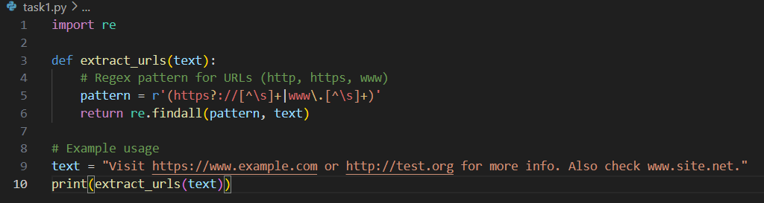

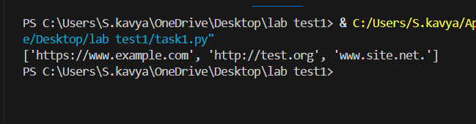

2) Given a list of books with their genres, write a Python function that recommends

books based on a user’s preferred genre. Use the Cursor AI tool. Use few shot prompting

prompt:

creating a functionof the books with their recommed book for a uses

example dune genre science fiction

pride and prejubice

romace

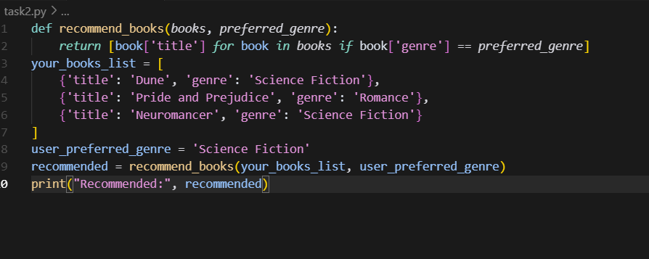

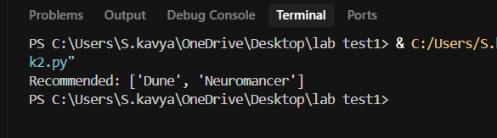

3. (2 Marks) Write a Python program that generates all prime numbers between start and end

(both inclusive) entered by the user. Use GitHub Copilot along with VS Code. Use few shot

Prompting

Create and function used prime numbers and start and end includes of the python of the code examples 1to 20 1 to 100 ,40 to 80

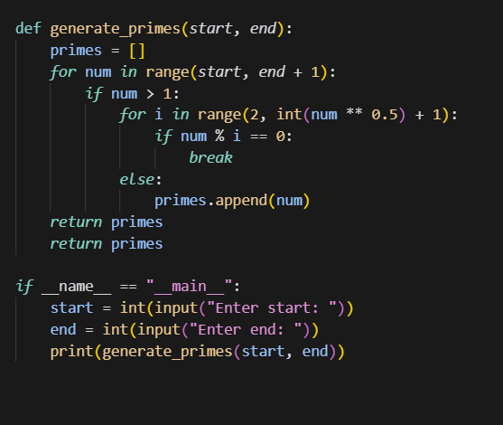

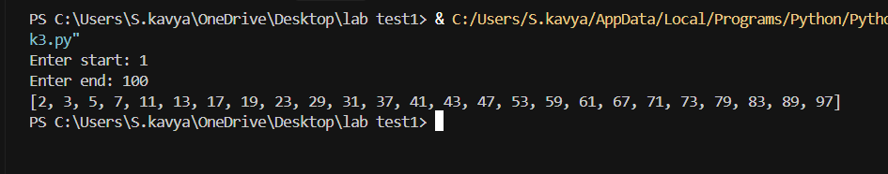

4. (2 Marks) Write Python code that takes a list of student names and generates institutional

email IDs in the format: <firstletter><lastname>@sru.edu.in Example: "Anita Sharma"→

asharma@sru.edu.in. Use GitHub Copilot along with VS Code. Use few shot prompting.

Prompt:

Creating the a python instucation for the emails of the in the format

Example:

Anitha sharma

Ravi kumar

Priya singhsa

